CONTENT

1 PURPOSE 2
2 SCOPE 2
3 RESPONSIBILITES 2
4 REQUIRED TOOLS, MATERIALS, & SAFETY EQUIPMENT 3
4.1 Tools 3
4.2 Materials 3
4.3 Access and security prerequisites 3
5 QUALITY & SAFETY CRITERIA 3
5.1 Data protection precautions 3
5.2 Quality checkpoints 3
6 COMMON ERRORS & TROUBLESHOOTING 4
7 WORK STEPS 5
7.1 Start the tool and sign in 5
7.2 Import events from a file 5
7.3 Sync events from the CycurGUARD backend 6
7.4 Read the Overview 7
7.5 Search and read events 8
7.6 Review vehicles and VIN details 9
7.7 Triage alerts 10
7.8 Work a case 11
7.9 Tune detections, suppression rules and the event catalog 14
7.10 Set up two-step sign-in 15
7.11 Manage users, tokens and sign-in rules 17
7.12 Check the audit log 18
7.13 Back up and remove data 19
8 FLOW 20
8.1 PROCESS FLOW OVERVIEW 20
9 DOCUMENTS & RECORDS 20
10 REVISION HISTORY 21

PURPOSE
This manual explains how to work with Fleet IDS SIEM, the local tool for analysing the events that the in-vehicle IDS uploads to the CycurGUARD backend. It covers loading events, finding what matters, handling alerts as cases, reading vehicle details decoded from the VIN, and administering users and the audit trail.
The intended outcome is that every analyst handles IDS events the same way, that each finding can be traced to the events and the person behind it, and that no event data leaves the analyst’s computer.

SCOPE
Applies to everyone who analyses vehicle IDS events with Fleet IDS SIEM: analysts, viewers and administrators of the vehicle cybersecurity team. The tool runs on the user’s own computer (http://localhost:8765) and reads events from an export file or from the CycurGUARD backend.
Vehicle details are decoded with the INEOS Grenadier VIN decoder, Corp-P2-ENG-0128 rev 001 (EU/ROW and US/Canada variants).
Not covered: operating the CycurGUARD backend, the TARA itself, and the vehicle IDS configuration.

RESPONSIBILITES
Each person works under one of three roles. The role is set by an administrator and decides what the tool allows. An API token can only reduce, never raise, the access of its owner.
Role | Responsibility
Viewer | Read events, vehicles, alerts and cases. Cannot change anything.
Analyst | Everything a viewer can do. Triage alerts, create and work cases and case reports, add notes, create suppression rules, classify event types, import data, run detections.
Case owner | The analyst named on a case. Drives it to closure, keeps the checklist current and records the findings and the decision.
Administrator | Everything an analyst can do. Manages users, sign-in and token rules, the backend connection, detection rules and data deletion. Reads and verifies the audit log.

REQUIRED TOOLS, MATERIALS, & SAFETY EQUIPMENT

Tools
A computer with Python 3.9 or newer and a current web browser. The tool uses only the Python standard library. Excel (.xlsx) import additionally needs the openpyxl package (pip install -r requirements.txt).

Materials
One of the following, plus the VIN decoder document if you want to check how a VIN was read:
• an event export from the backend (CSV, Excel or JSON), or
• the backend address and an API token with view permission for reports (set up by an administrator).
• INEOS Grenadier VIN Decoder Global, Corp-P2-ENG-0128 rev 001.

Access and security prerequisites
• A personal account. Ask an administrator to create it; never share one account.
• A computer that only you can use, because events contain VINs and the database file data/siem.db holds all data and the backend token.
• The tool must stay on this computer. Do not expose its port to a network.

QUALITY & SAFETY CRITERIA

Data protection precautions
• The tool listens on 127.0.0.1 only and uses plain HTTP, which is safe on localhost and not on a network.
• The database file is readable by you only. Keep it that way and do not copy it to shared drives.
• The backend token is stored in the database in clear text because it must be sent to the backend. Use a token with the least permission that works.
• An API token is shown once when you create it. Copy it immediately and store it in a password manager.
• Exports (Events → Export CSV, Audit log → Export CSV) contain VINs and user names. Handle them as confidential.

Quality checkpoints
• After every import, open Data → Data quality and read the four figures: no timestamp, implausible timestamp, no ECU name, VINs that are not 17 characters.
• Times are always UTC. Events without a plausible time still count everywhere but are missing from timelines and date ranges.
• Classify new event types in the Event catalog, because the severity of an event type drives alerts and risk.
• Before the first backend sync, use Check connection and compare the three sample events with the backend.
• On a vehicle page, read the VIN check digit verdict and any “Not in the decoder” note before relying on the decoded details.
• Verify the audit log regularly with Verify integrity (administrators).

COMMON ERRORS & TROUBLESHOOTING
Problem | Likely cause | What to do
Browser cannot open the page | The tool is not running, or it runs on another port. | Start it with python idssiem.py and open http://localhost:8765. Use --port or the PORT variable for another port.
Sign-in refused for 5 minutes | Five wrong passwords lock the account. | Wait 5 minutes, or ask an administrator to reset the password.
The second step does not accept my code | The phone clock is off, or the code was already used. | Wait for the next code. Check that the phone time is set automatically. Or use a recovery code.
Passkey button is missing or refused | The tool was opened under another address, so the browser has no host name for the passkey. | Open http://localhost:8765 instead.
Administrator locked out | Forgotten password. | On the computer that runs the tool: python idssiem.py --reset-password USER.
A button answers “not allowed” | Your role is viewer, or your API token has view permission only. | Ask an administrator for the analyst role.
No Users or Audit log in the menu | Both are for administrators. | Ask an administrator.
Excel import fails | The openpyxl package is missing. | Run pip install -r requirements.txt, or export CSV instead.
An alert is missing from the open list | A suppression rule hides it. | Open the Suppressed tab on Alerts. The rule, its reason and its expiry are under Detections → Suppression rules.
Event count did not grow after a second import | Rows already imported are recognised. | Nothing to fix. Re-importing never creates duplicates.
Events missing from the timeline | They have no usable timestamp: empty, before 2022-01-01 or in the future. | Search ts:invalid to list them. The cut-off date can be changed on the Data page.
Sync says the token was refused | A short-lived login token expired. | Use a CycurGUARD API token with view permission, then run Test connection on the Users page.
Sync stopped half way | Network or backend failure, or Cancel. | Start the sync again. It continues where it stopped and never doubles events.
Vehicle shows “Unknown (X)” or a wrong check digit | The VIN has a code that decoder rev 001 does not list, or it contains a typo. | Check the VIN against the source and the decoder document. A wrong check digit is a hint, not proof, of a typo or spoofed VIN.

WORK STEPS
Follow the steps in order the first time. Later you will mostly use steps 7.4 to 7.8.

Start the tool and sign in
1. Open a terminal in the tool’s folder and run python idssiem.py.
2. Open http://localhost:8765 in your browser.
3. On the very first start the tool asks for the first administrator. Enter a user name, a display name and a password of at least 10 characters, then choose Create administrator.
4. On every later start choose your account and sign in. If you have set up two-step sign-in (section 7.10), a second screen asks for a code or a passkey. The session ends after 8 idle hours by default.
5. Use Theme in the top bar to switch between light and dark.
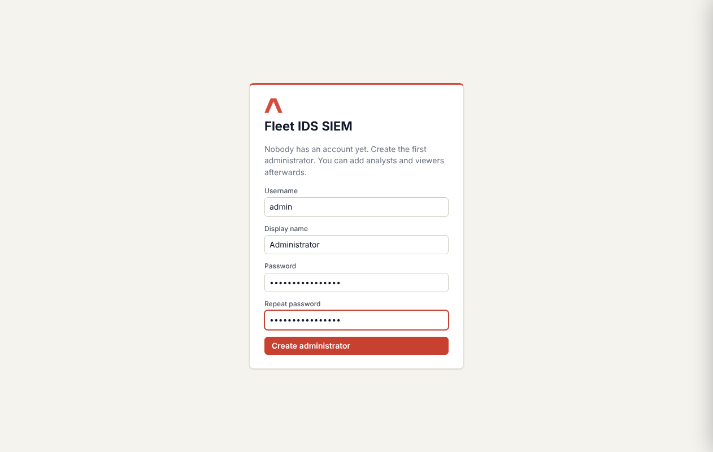
Figure 1: First start: create the first administrator

Import events from a file
1. Choose Data in the menu (or Import data in the top bar).
2. Drop the export on the import area or choose Choose a file. CSV, Excel (.xlsx) and JSON are accepted.
3. Wait for the result. It shows how many rows were new, how many were already known and how many were invalid.
4. Open Data quality on the same page and check the four figures (see section 5.2).
5. Detections run automatically after the import. Check Alerts for new entries.
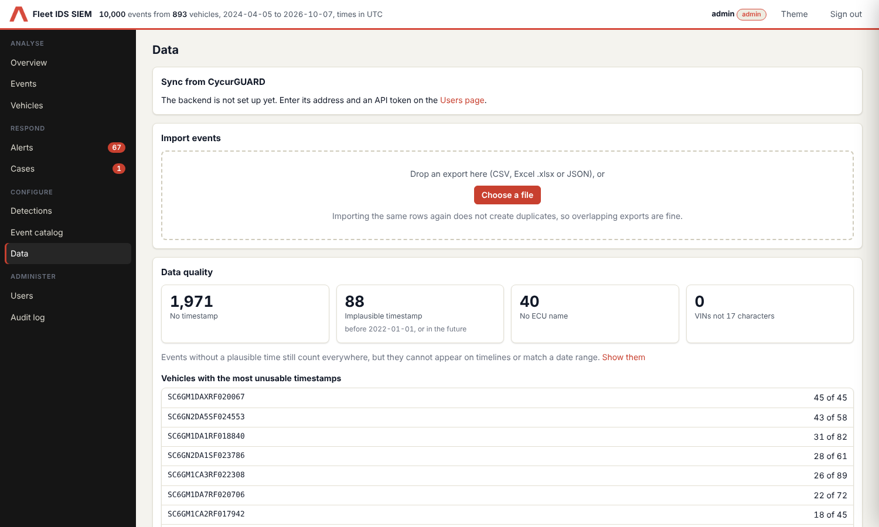
Figure 2: Data page with import area and data quality
Note: Importing the same rows again never creates duplicates, so overlapping exports are fine. Remove events next to an import in the import history takes that import’s events out again.

Sync events from the CycurGUARD backend
One-time setup (administrator):
1. Open Users → Backend connection and enter the backend address and an API token.
2. Choose Test connection to check what you typed before saving. Then save. The token is stored on this computer and never shown again.
Each sync (analyst):
1. Open Data → Sync from CycurGUARD and choose Check connection. It shows the backend version, how many events a sync would fetch and the first three events.
2. Choose Sync now. The progress is shown live and you can cancel. The first sync fetches everything; later syncs fetch only what is new.
3. When it finishes, detections run and the sync is written to the audit log.
Automatic sync (administrator): under Users → Backend connection → Automatic sync, tick the box, choose how often (5 minutes to 24 hours) and choose Save schedule. The tool then pulls new events in the background while it is running. Do the first sync by hand first, because you choose how far back it goes. Runs that find nothing new are not written to the audit log. The Data page shows the interval and the next run.
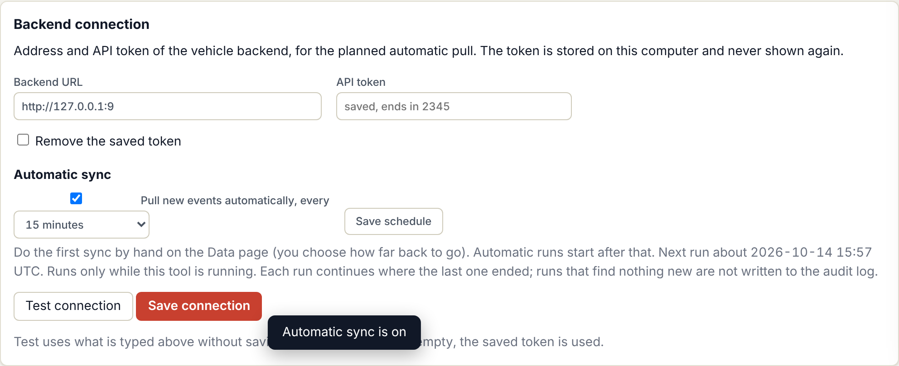
Figure 3: Automatic sync on the Users page
Start over (administrator): choose Start over on the Data page when you want a complete sync from the beginning. Stored events are kept and are not duplicated; events that were synced before get their backend details filled in when they are fetched again. On the command line use --sync --restart.
Backend details: each synced event keeps what the backend reported: the CycurGUARD severity (1 to 3), the report type, the named fields with their meaning, the CAN message (id, name, sender and receivers), the violated rule with its limits and the measured values, and the time window when the backend gave no exact time. They are shown in the event drawer. An administrator can upload the CycurGUARD severity configuration on the Data page so that the configured meaning of an event is shown as well. Show all fields lists which fields the backend delivers.
The same can be done on the command line: python idssiem.py --sync (add --days 90 to limit the first run to the last 90 days). The environment variables CYCURGUARD_URL and CYCURGUARD_TOKEN override the saved values.

Read the Overview
The Overview is your daily starting point. It shows the totals (events, vehicles, open alerts, open cases, high or critical events, events without a usable time), the events over time and the most frequent event types, vehicles and ECUs.
• Events over time: choose the colour (severity, ECU, type, category). Drag across the chart to select a period, then choose Show these events.
• Fleet by: switch between model year, variant, body, engine, hand of drive and market. Each bar shows vehicles, events and high-severity events. Click a bar to list those vehicles.
• Every figure and bar is a link to the matching list.
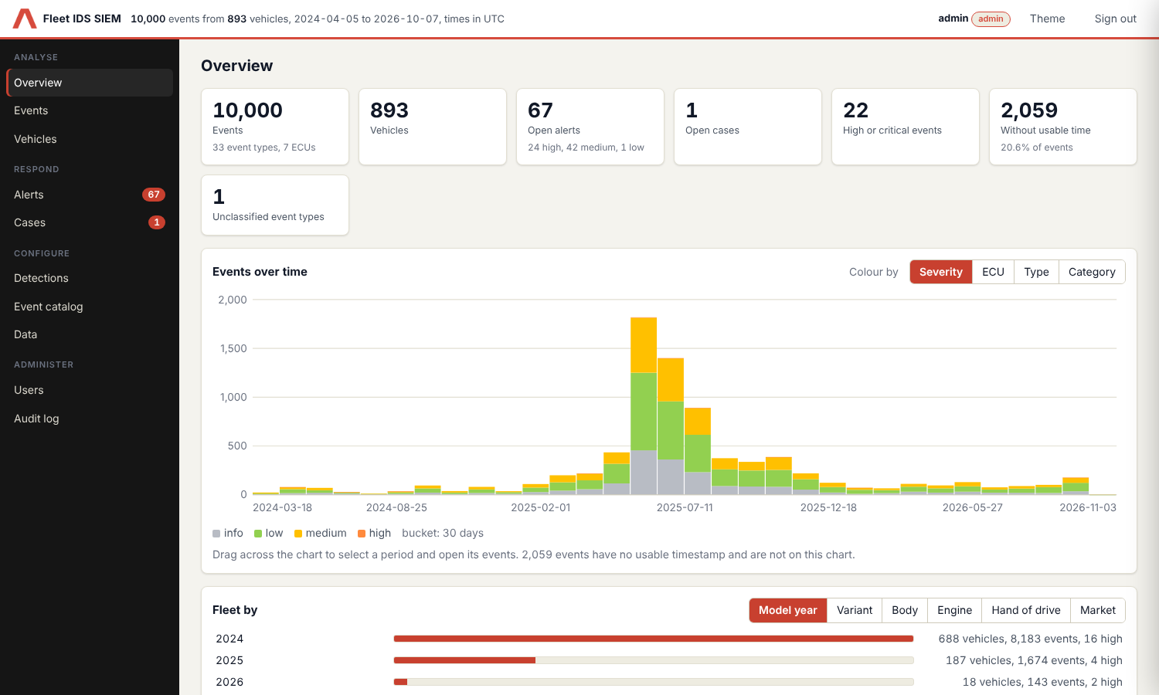
Figure 4: Overview with the Fleet by panel

Search and read events
1. Open Events. Type a query in the search box, set From and To if needed (UTC), then choose Search.
2. Narrow the result with the facets on the left (severity, ECU, category).
3. Select a row to open the event drawer. It shows the event, the backend details (section 7.3), the alerts that cover the event and its case, and related events of the same vehicle. Add an analyst note there; it is attributed to you.
4. The column Alert, case shows which alerts cover each event (for example #42) and the case they belong to. Use the filters Alert (covered, not covered) and Case (in a case, not in a case) to find events that nobody has looked at yet.
5. Choose Export CSV to save the current result.
Search term | Matches
vin:SC6GM1 | VINs containing the text
ecu:BCM | Events reported by that ECU
sev:high | Severity (info, low, medium, high, critical)
name:CRC | Event name
id:, type:, cat:, desc: | Event id, event type, category, description
ts:invalid | Events without a usable timestamp
-type:can | A minus in front excludes the match
Terms can be combined, for example vin:SC6GM1 ecu:BCM sev:high -type:sev.
An alert covers an event when the event lies inside the filter of the alert (vehicle, event type, ECU and time window). These are the same events that the alert shows. An event counts as being in a case when one of the alerts that cover it is linked to that case, whatever the status of the alert.
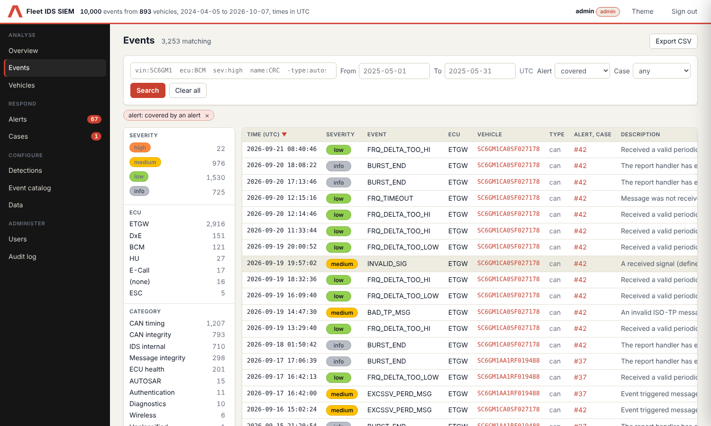
Figure 5: Events page with the Alert and Case filters and the Alert, case column

Review vehicles and VIN details
1. Open Vehicles. The list is ordered by risk; low counts 1, medium 3, high 10 and critical 25 for every event. Sort by any column, search for a VIN or part of one, or filter by a decoded value (a chip shows the filter; the × removes it).
2. Select a vehicle. The page shows its totals, Vehicle identity, timeline, what each ECU reported and its alerts.
3. Vehicle identity is decoded from the VIN: model and variant, body, engine, hand of drive, market, model year, plant and serial number. The VIN is also split into its fields. Choose any red value to list all vehicles that share it.
4. Read the Check digit line. “Wrong” means the VIN does not pass the standard check calculation: look for a typo or a spoofed VIN.
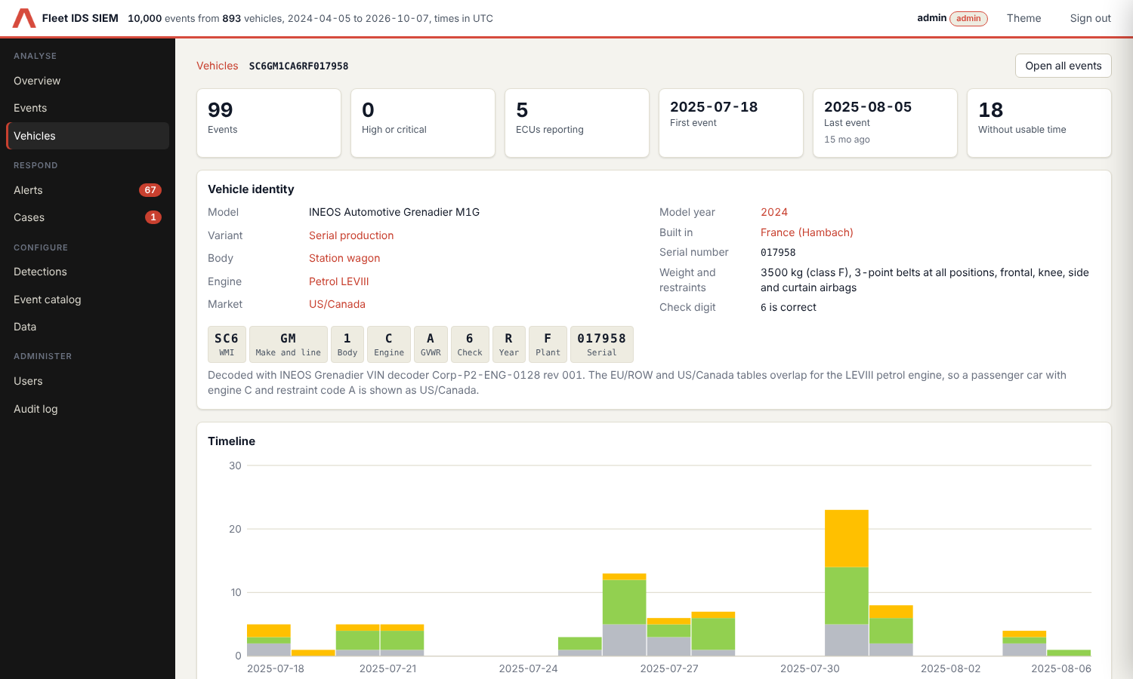
Figure 6: Vehicle page with the decoded VIN
Note: The EU/ROW and US/Canada tables overlap for the LEVIII petrol engine. A passenger car with engine code C and restraint code A is shown as US/Canada; trucks are recognised by the WMI SH7. Codes the decoder does not list are shown as “Unknown (X)”, never guessed.

Triage alerts
Detections turn events into alerts. Each alert belongs to one detection and usually to one vehicle.
1. Open Alerts. The tabs show Open, All, Resolved, False positive and Suppressed. Filter by text, severity, detection or case state.
2. Select an alert to open its drawer. It shows the events behind it, the history and the notes.
3. Decide: set the status In progress and an assignee, Resolved, or False positive, and add a note that explains the decision.
4. To handle several alerts alike, tick them and use the bulk actions: set a status, Create case (one new case for all of them) or Add to case (all of them into an existing case). An alert can be in one case only.
5. If the drawer shows May belong to an existing case, the same vehicle already has a case for the same event type within 30 days. Open it, or add the alert to it. Nothing is linked automatically. The alert list shows the hint as “maybe #N”.
6. If the alert needs real investigation, create a case from it (next step).
7. If the same harmless pattern keeps coming back, choose Suppress similar alerts in the drawer (analyst). See section 7.9.
Note: Alert and case titles are real links. Right-click and choose Open in new tab (or Ctrl-click, or middle-click) to open the alert or the case in its own tab. On a vehicle page a click on an alert opens its details in place and does not leave the vehicle.
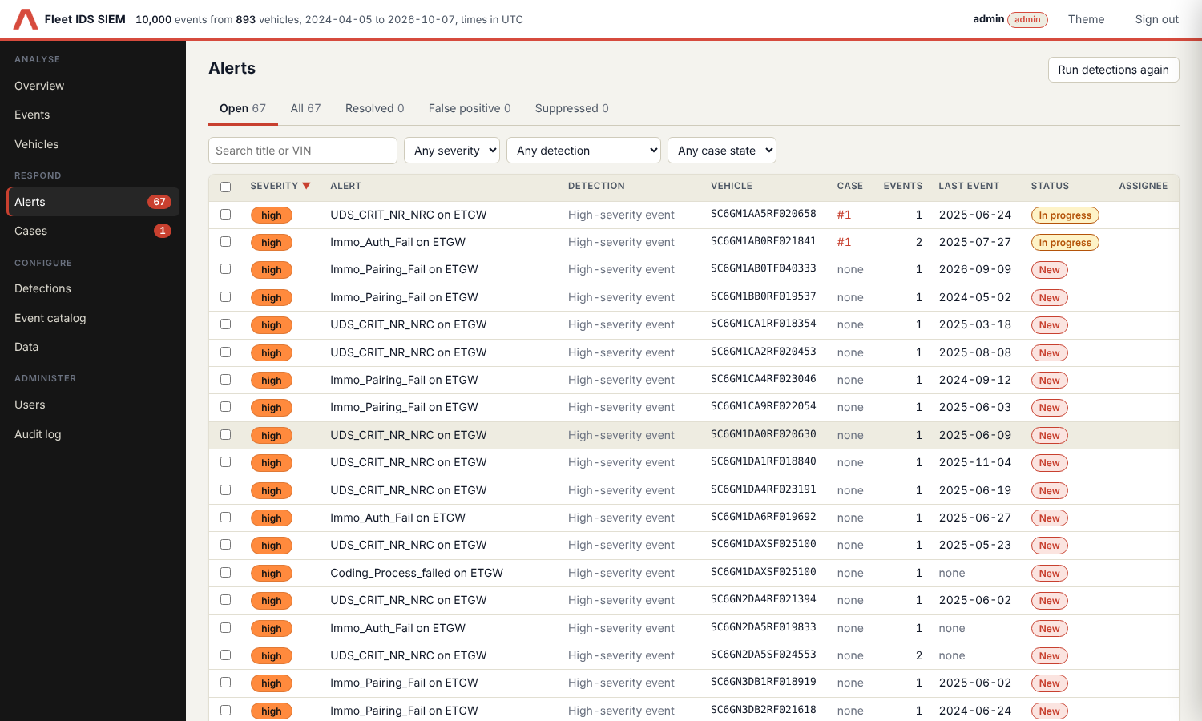
Figure 7: Alert queue
Note: Alerts keep their status, assignee and notes when detections run again. Choose Run detections again after you changed a rule or the event catalog.

Work a case
1. Create the case from one or more alerts (alert drawer or bulk action). The linked alerts change to In progress.
2. Give the case a clear title, write what happened and what is known in the summary, and set severity, owner and due date.
3. Work through the checklist. The default tasks are: review the linked events and the vehicle history; check whether other vehicles show the same pattern; confirm with the system or component owner; assess the impact on TARA threat scenarios and CSMS; decide on the response and whether reporting is needed; document the findings. Add or remove tasks as needed.
4. Write the result of each step into the box under the task, for example what you found or decided. It is saved when you leave the box and appears in the activity log and in the case report.
5. Set the status to Investigating or Waiting as the work moves. Link or unlink alerts when the picture changes.
6. Write the root cause, affected vehicles and decision into Findings and decision. Add comments for anything others should know.
7. Choose Close case and pick a resolution. Open alerts of the case can be resolved at the same time. Reopen brings a closed case back.
8. Choose Export report at any time to open a printable report of the case. In the print dialog choose Save as PDF. Each export is written to the audit log.
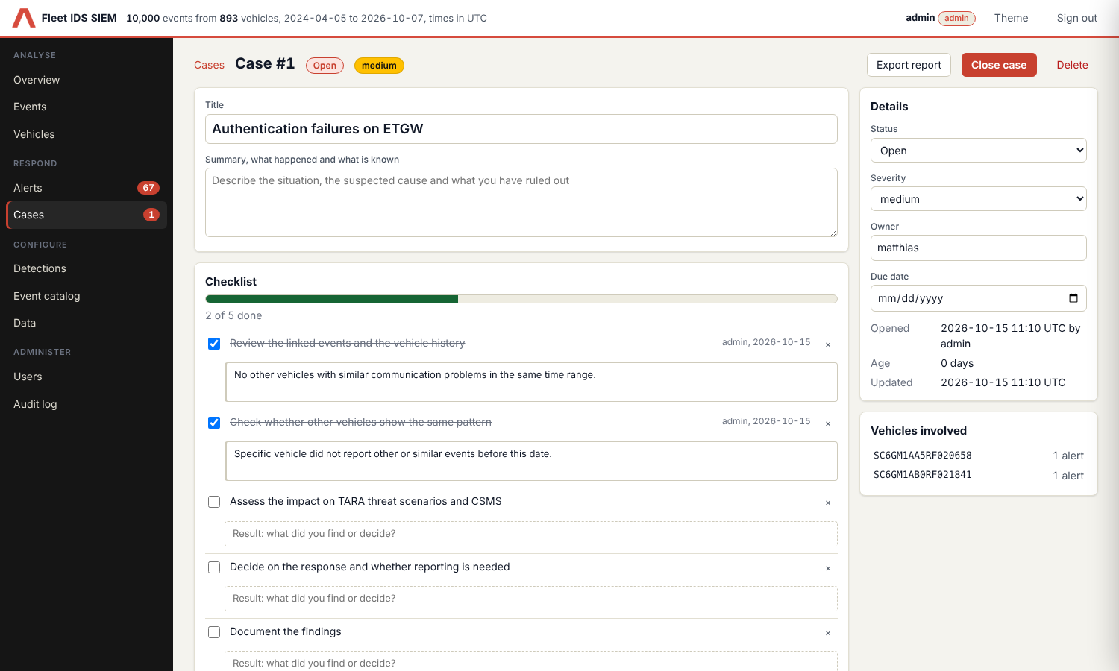
Figure 8: Case with checklist results, details and linked alerts
The report contains the case facts, summary, findings and decision, the vehicles with their decoded VIN, the linked alerts, the checklist and the full activity log, all in UTC.
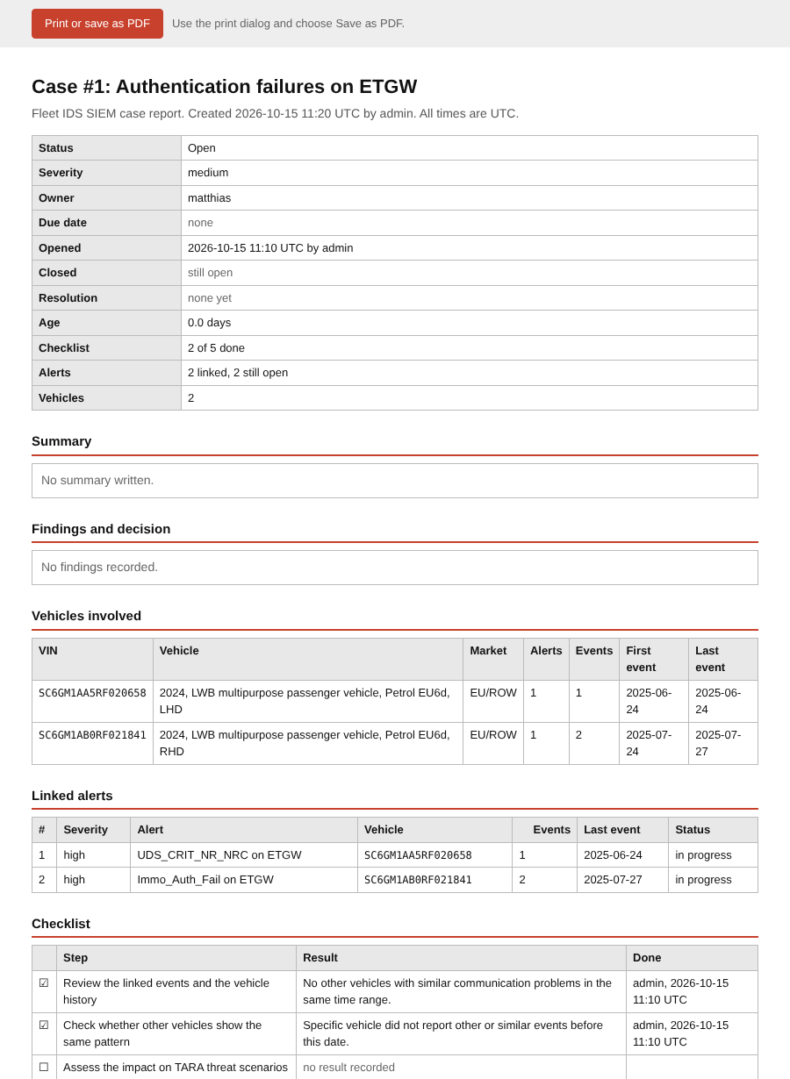
Figure 9: Case report (top part)
The Cases page starts with a dashboard: cases by status, overdue and ownerless cases, age, cases opened and closed per week, time to close, severity, owners and resolutions.

Tune detections, suppression rules and the event catalog
1. Open Detections (administrator to change, everyone to read). Six rules are available; each can be switched on or off and tuned.
2. Open Event catalog to set the severity and category of each event type. The defaults are only a starting point; adjust them to your TARA.
3. Unclassified event types raise their own alert until you classify them.
4. Silence a known-benign pattern with a suppression rule (below).
Detection | What it finds
High-severity event | Event types at or above a minimum severity, per vehicle, ECU and type.
Event burst | N or more events of one type on one vehicle within a time window (default 3 in 60 minutes). Raises the severity by one level.
Multiple ECUs affected | One vehicle reports non-info events from at least N ECUs on the same UTC day (default 3).
Vehicle outlier | A vehicle with far more non-info events than the fleet average (default 3 standard deviations, at least 10 events).
Fleet-wide spike | A UTC day with far more non-info events than the daily average. Neighbouring spike days are merged.
Unclassified event type | An event type that is not yet classified in the catalog.
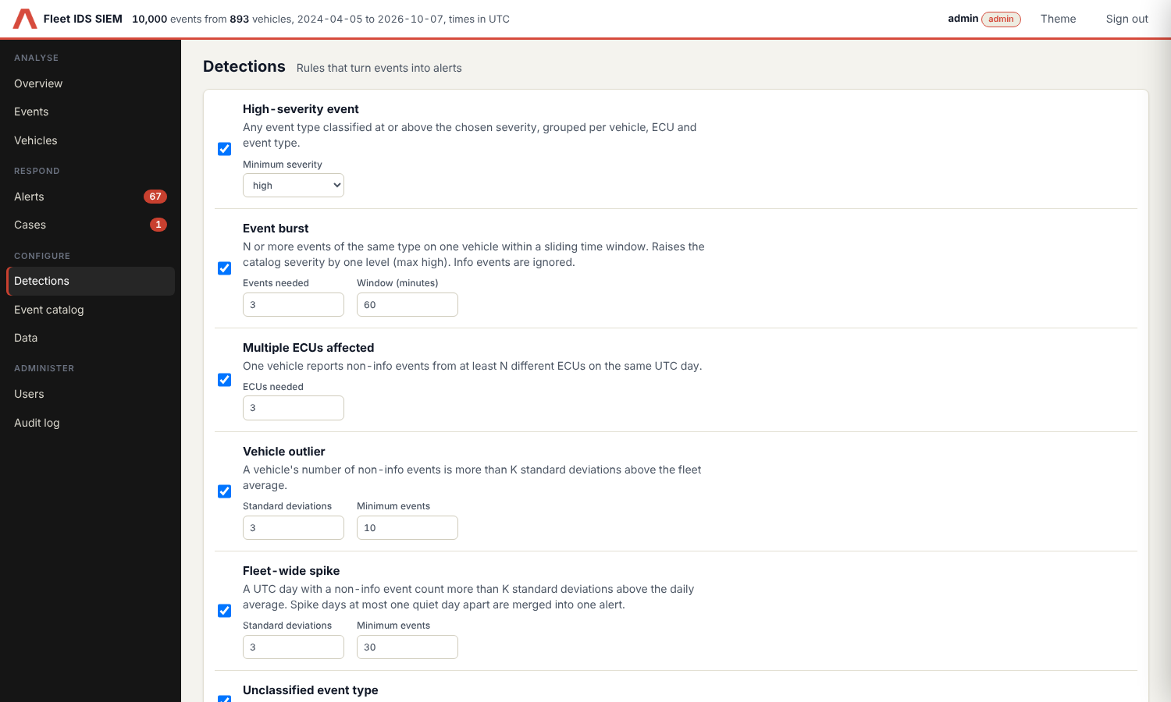
Figure 10: Detection rules
Suppression rules hide alerts for a pattern you have judged harmless, for example an event type that a bench diagnostic tool always triggers.
1. Open the alert and choose Suppress similar alerts, or choose New rule under Detections → Suppression rules.
2. Choose what the rule matches: detection, ECU, event type and, if wanted, one vehicle. Leave a field empty to match anything. At least one field is required.
3. Write the reason. Everyone who opens a suppressed alert reads it, and the audit log keeps it.
4. Choose how long the rule lasts (30 days to 1 year, or no expiry; 90 days is preset) and create the rule.
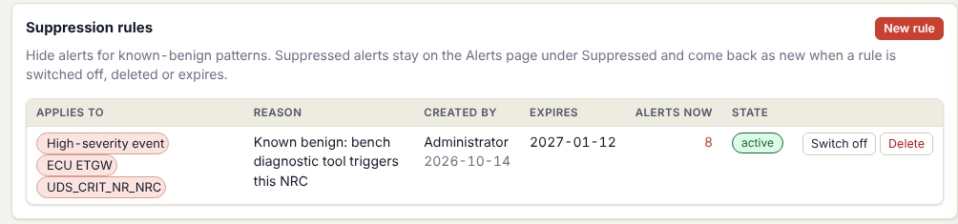
Figure 11: Suppression rules on the Detections page
• Matching alerts get the status Suppressed and move to the Suppressed tab. They are not deleted and still count there.
• Alerts that someone already works on (in progress or in a case) are never suppressed.
• When a rule is switched off, deleted or expires, its alerts return to New.
• Events are never hidden. Only the alerts made from them are.

Set up two-step sign-in
A second step means a stolen password is not enough. You can use an authenticator app, a passkey, or both. Open Account → Two-step sign-in.
1. Enter your password in the field at the top of the panel. Every change in this panel asks for it.
2. Authenticator app: choose Set up, scan the QR code with your authenticator app (or type the key), enter the 6-digit code and choose Turn on.
3. Passkey: open the tool as http://localhost:8765, enter a name, choose Add a passkey and confirm with your fingerprint, face, PIN or security key.
4. Recovery codes: the first method you add creates ten recovery codes. Copy or download them now. They are shown only once.
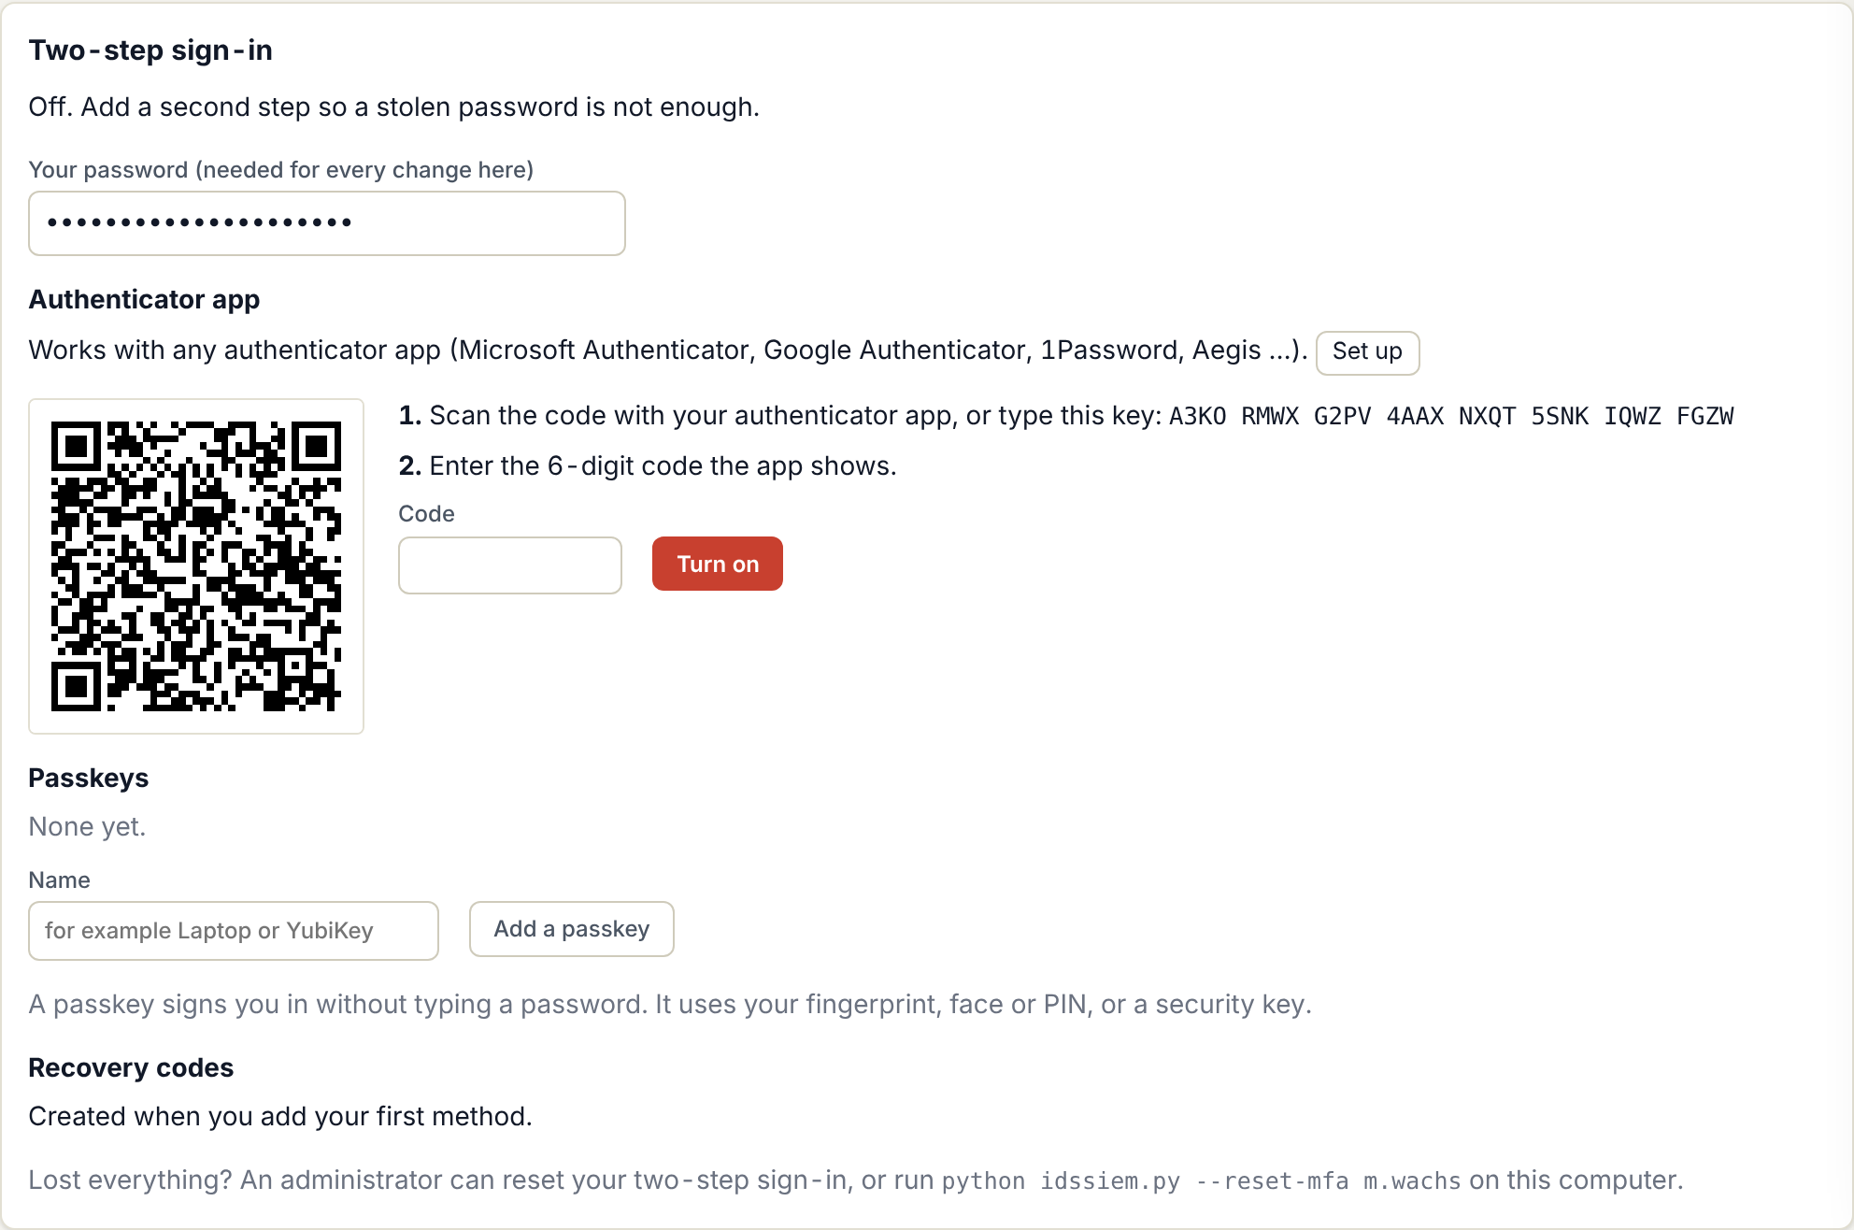
Figure 12: Setting up the authenticator app
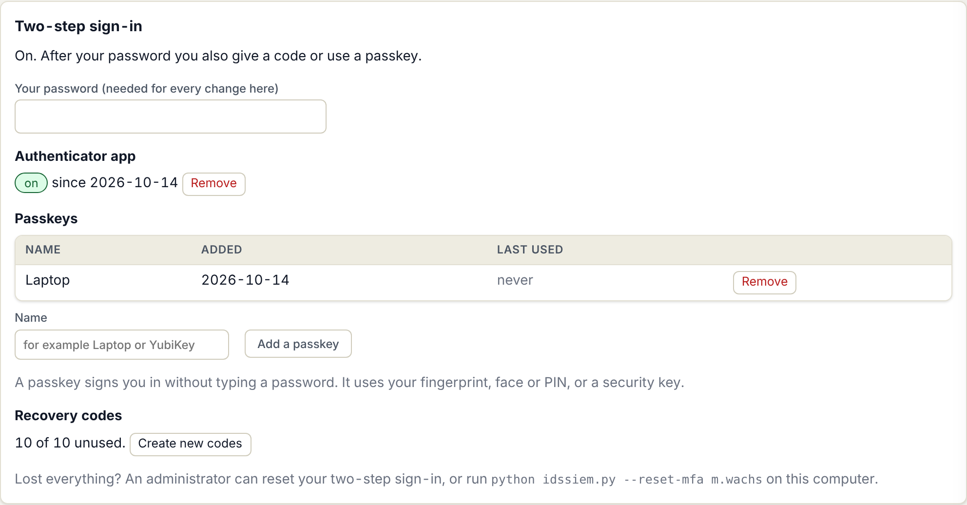
Figure 13: Two-step sign-in with an authenticator app and a passkey
Signing in afterwards: enter your password, then the code from the app, a recovery code, or choose Use a passkey. With a passkey you can also choose Sign in with a passkey on the first screen and skip the password.
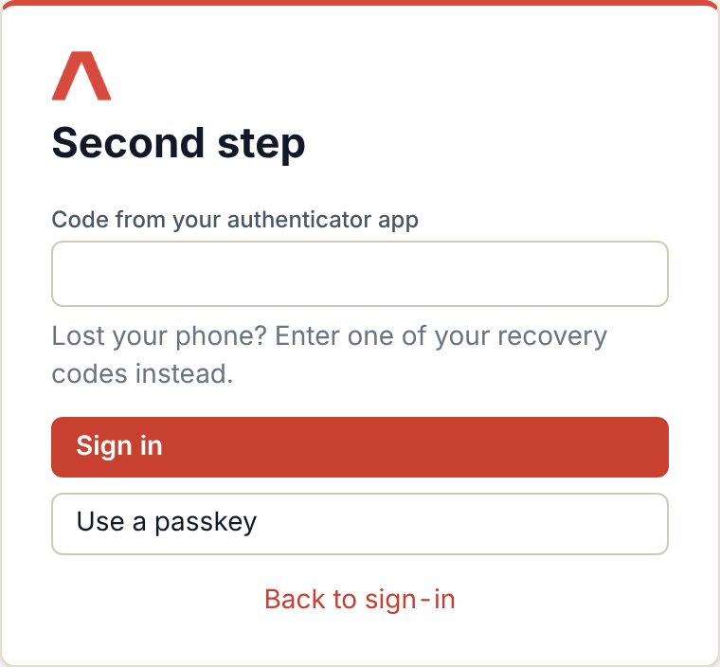
Figure 14: Second step of the sign-in
• Wrong codes count like wrong passwords: after 5 failures the account is locked for 5 minutes.
• Passkeys work only at http://localhost:8765, not at an IP address (127.0.0.1 is redirected to localhost). Authenticator codes work at both.
• Lost your phone or key? Use a recovery code, then set up again. If you have none, ask an administrator to reset your two-step sign-in, or run python idssiem.py --reset-mfa USER on the computer.
• An administrator can require two-step sign-in for everyone (Users → Sign-in and token rules). Anyone without it can then only open the Account page until it is set up. API tokens are not affected.

Manage users, tokens and sign-in rules
Your own account: choose your name in the top bar. There you change your password and create or revoke your own API tokens. Give a token a permission (view, modify, full) and an expiry. It is shown once.
Administrators open Users:
1. Choose New user, enter user name, name, role and a starting password, and tell the person the password in person.
2. Select an account to change its role, reset its password, deactivate or delete it. Such a change signs the person out everywhere.
3. To help someone who lost their phone or passkey, select the account and choose Reset two-step sign-in. The person is signed out and can set it up again.
4. Under Sign-in and token rules set the idle session time, the minimum password length, the default and longest token lifetime, whether two-step sign-in is required, and whether API tokens are allowed at all. Switching tokens off stops every existing token at once.
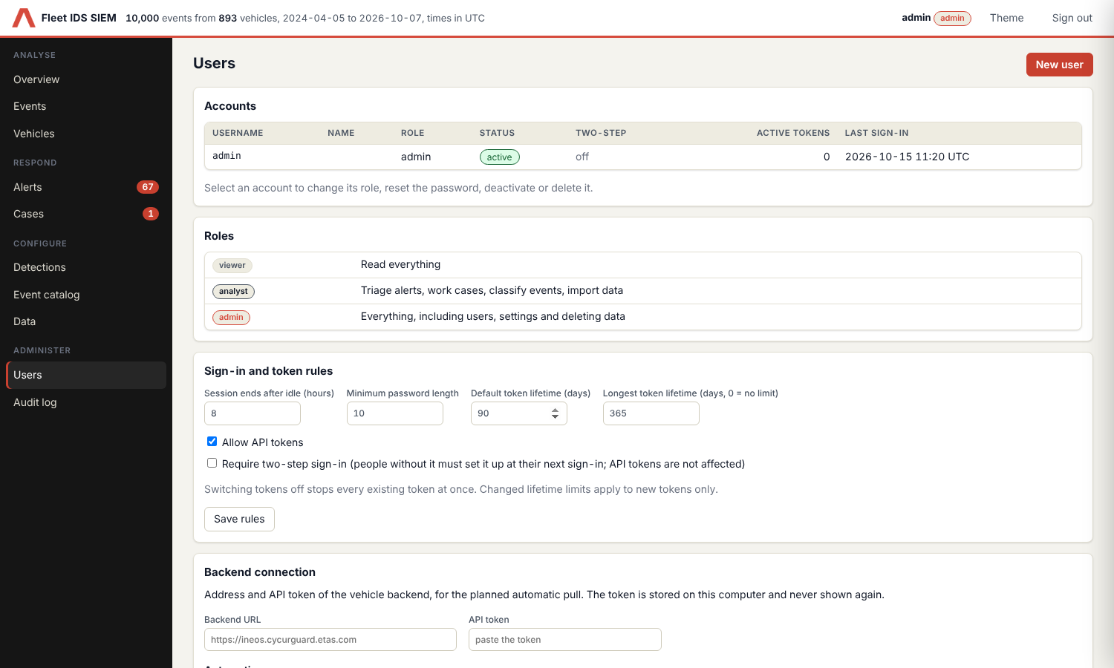
Figure 15: Users page
A token is used with the header Authorization: Bearer ids_… on the tool’s API. The effective access is the lower of the token and its owner’s role.

Check the audit log
1. Open Audit log (administrator).
2. Search for a person, action or target, or filter by person, action group and date.
3. Choose Verify integrity to check the hash chain. It reports where the chain breaks.
4. Choose Export CSV to hand the log to an auditor.
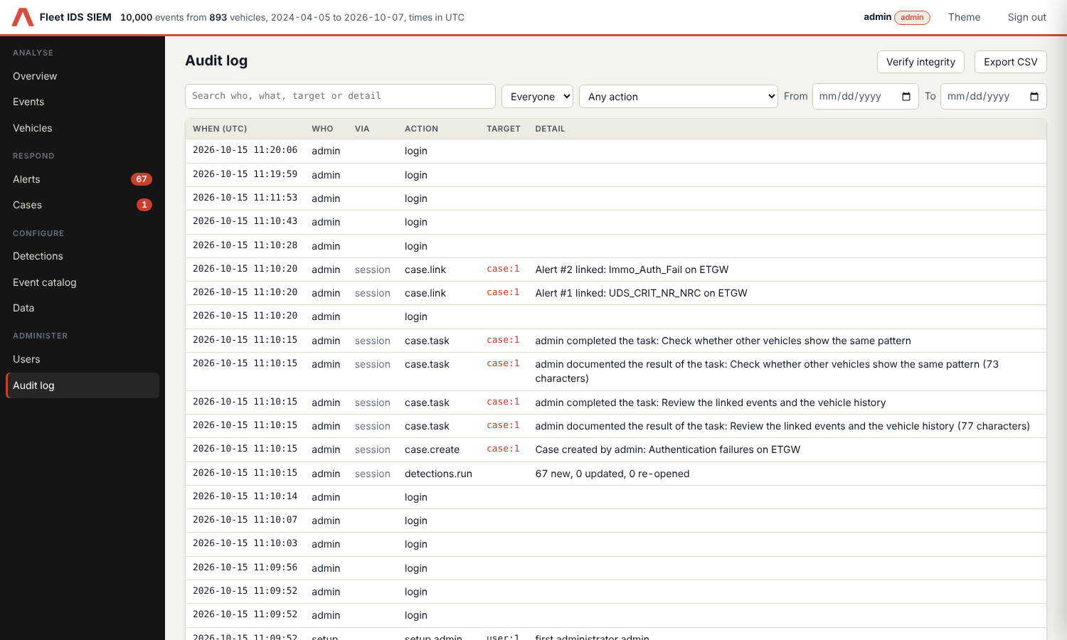
Figure 16: Audit log
Every state-changing action is recorded: sign-ins and failures, user and token changes, alert and case work, suppression rules, case reports, imports, syncs, detection runs and exports. Note text is not copied; the log only records that a note was added. Entries cannot be changed or deleted in the application, not even by “Delete all data”.
Limit: The chain detects edited entries and entries deleted from the middle. Someone who can write the database file could recompute it, and cutting off the newest entries goes unnoticed unless you noted the latest hash. Treat it as evidence, not a vault.

Back up and remove data
• All data is in data/siem.db. Stop the tool and copy that file to back it up. Set the variable IDS_SIEM_DB to use another location.
• Data → Delete everything (administrator) removes all events, alerts, cases and notes after you type the confirmation. Catalog, settings and the audit log stay.
Lean Tip: Start each day on the Overview, then work the Alerts queue from the highest severity, and only open a case when an alert needs more than a decision.

FLOW
R (Responsible), S (Supporting), I (Informed): the roles named are those of section 3.
R | S | I | Input | Output | Activity | Documents
Analyst | Administrator |  | Event export or backend | Events in the tool | Import a file or sync from CycurGUARD, check data quality | Export file  Backend token
Analyst |  | Administrator | Events | Open alerts | Run detections, review the alert queue | Detection settings  Event catalog
Analyst | Case owner | Administrator | Open alert | Alert resolved, false positive or case | Triage the alert, add a note, create a case if needed | Alert notes
Case owner | Analyst | Administrator | Case | Closed case with findings and resolution | Work the checklist, record findings, close | Case record  VIN decoder
Administrator |  | Analyst | Audit log | Verified log | Verify integrity and export on request | Audit log CSV

PROCESS FLOW OVERVIEW

Alert and case life cycle
Alert: New → In progress → Resolved or False positive. A matching suppression rule moves a new alert to Suppressed. An alert becomes In progress when you set it or when a case is created from it. A resolved alert is re-opened if new matching events show up, and the case it belongs to is told.
Case: Open → Investigating or Waiting → Closed. Closing needs a resolution and can resolve the case’s open alerts. A closed case can be reopened.

DOCUMENTS & RECORDS

# | Description
1 | INEOS Grenadier VIN Decoder Global, Corp-P2-ENG-0128, revision 001
2 | Fleet IDS SIEM repository and README: github.com/rng0xff/idssiem
3 | CycurGUARD backend API documentation (Swagger): ineos.cycurguard.etas.com/docs
4 | Event and audit log exports (CSV), created in the tool on request

REVISION HISTORY
Revision | Description of Change | Editor | Date
001 | Initial document | Matthias Wachs | 15.10.2026

